IS THERE A COST?

Regular 4-H members: $15
Mini Members: FREE
WHY JOIN?

4-H is a great chance for you to meet kids of all ages and participate in projects that interest you!

WHO CAN JOIN?

Marshall County 4-H offers both Mini and Regular 4-H!
Mini 4-H is for youth in grades K-2. Youth can enroll in up to 2
mini projects and learn the basics of 4-H
Regular 4-H is for youth in grades 3-12. Youth can be involved
in 4-H for 10 years, and can choose as many projects as they
would like from our list of over 80 projects!

HOW TO JOIN?

It is easy!

Go online to https://in.4honline.com and set up a profile.

Call the office at 574-935-
8545

Stop in: 112 W. Jefferson St. Room 304 in Plymouth!

Enrollment starts October 1st and ends May 15th.

Feel free to contact our office if you have questions or need help enrolling. We would be happy to help in anyway we can!

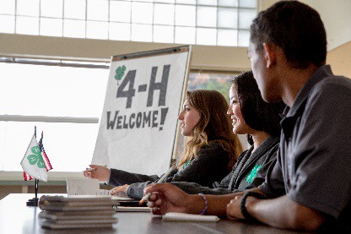Find us on Facebook: Facebook.com/MarshallCo4H

Find our website: Extension.purdue.edu/marshall

Find us on Instagram:
@marshco4h

Find us on Pinterest:
@marshallco4h

Find us on Twitter:
@marshco4h
PROJECT OPPORTUNITIES

We have lots of projects for many different interests! A few examples are:
• Architectural Models (Legos)
• Robotics
• Cupcake/Cake Decorating
• Livestock
• Arts and Crafts
• Model Rockets
• Photography
• Book Reading
A full list of our projects can be found at
our website:
https://extension.purdue.edu/Marshall
Go to the “Youth” Tab and click “4-H
Projects – Marshall County”

