Navigating the Updated Components of:
Special Considerations and Behavior (IIEP)

SECTION 1: General Guidelines to Developing Behavior Intervention Plans within IIEP

According to Article 7, a Functional Behavioral Assessment MUST be completed for:
- Initial Eligibility for services requirement
- Discipline (manifestation determination results in a causal relationship)
- When previous FBA already exists (revision)

Developing a Behavioral Intervention Plan: Two Parts-One Process

Developing a hypothesis for WHY the behavior happens  Functional Behavior Assessment (FBA) | Identifying the skill appropriate to the setting that need to be taught and learned  Behavioral Intervention Plan (BIP)

What if we aren’t sure if an FBA is needed?

The CCC can decide to recommend that an FBA is not needed at this time. If this option is chosen environmental supports, accommodations, and/or specially designed instruction must be determined and implemented.

If the CCC determines that an FBA is not recommended at this time:
- Document the decision in IIEP
- Follow through with the fidelity
- You will be required to indicate the CCC's plan to monitor the effects/impact of these behavior supports:
  - Type of Support
  - Location
  - Frequency
  - By Whom

**Would be a CC discussion/decision so a parent should be involved but there’s no consent required

**At the very least this becomes more data

An FBA may be based on a review of existing student information, based on new student information, or both sources

- The FBA that is based on existing data REQUIRES a notice of this decision be provided to the parent
- The FBA that is based on new information REQUIRES signed and informed parent consent

When BOTH sources (existing and new) are used, parent consent is REQUIRED!

Types of Existing Data
Education records | Mental health records
Behavior records | Academic assessment
Attendance records | Behavioral assessment
Progress reports | Social emotional assessment
Progress on IEP goals reports | Medical history or check-up
Use of accommodations | School nurse logs
Parent interview | Medications list/purpose  *pharmacist can give a list of all the medications and potential interactions between all of them
Teacher interview | Systematic observations across environments
Student interview | Environmental audit (PENT.ca.gov)

RESOURCES:
1. Evidence Based Intervention Network http://ebi.missouri.edu/
2. CEC, CCBD as a division and indicate that you choose Indiana. (Facebook, Twitter)
- Council for Children with Behavioral Disorders http://www.ccbd.net/teacherresources
- Council for Exceptional Children https://www.cec.sped.org/
3. Positive Environments, Network of Trainers (PENT) http://www.pent.ca.gov/
- information and resources for educators striving to achieve high educational outcomes through the use of proactive positive strategies.
- dedicated to increasing academic achievement and overcoming behavioral barriers to success for all students with and without disabilities.
4. MBST app to track behavior (FREE)
5. NCII National Center for Intensive Intervention https://intensiveintervention.org
6. Pacer Center https://www.pacer.org
7. Intervention Central https://www.interventioncentral.org/behavioral-intervention-modification
8. PBIS World http://www.pbisworld.com/
9. Indiana IEP Resource Center https://www.indianaieprc.org/

Analysis of FBA data
- Review the FBA data (evaluation summary) as a team
- Bring any collected data to your meeting in a format that can be discussed by the members
  - Assessment summaries
  - Observation data (scatter plots, graphs, ABC charts)
  - Interview summaries
  - Look for patterns

Typical hypotheses of the function of behavior:
- Interfering behavior that is maintained by obtaining access to something desirable: attention, activities, objects, power or control of the situation, etc
- Interfering behavior that is maintained by escaping or avoiding something undesirable: people, activities, events, demands, tasks, etc
- Interfering behavior attributed to weak or missing skills, are considered a skill deficit

The FBA ends with the hypothesis statement:
- FBA summary hypotheses: (under X conditions the student is likely to do Y for Z reasons)
  - Example: Brittany throws herself down on the floor kicking and screaming when independent work time ends to avoid working in a group with four classmates
  - Example: When the class does round robin reading Carmen echo’s the student reading aloud to get the attention of peers in her social studies class

Evidence Based Practices (EBP):
- Have had valid research resulting in evidence of the effectiveness of intervention
- Show direct evidence of a change in student outcomes as a result of intervention
- Have been published in peer reviewed journals or other peer reviewed outlets
- Have no credible contradictory evidence
- Increase the probability of success
- There is no guarantee that a strategy will work for your student, however an EMP has a higher likelihood of being effective
- The best EBP is the one that works for your student
  - Handout has strategies but not all of them are evidence based

When they qualify for ED they have to have an FBA; however they do NOT have to have a BIP if it is not needed or no longer needed.

SECTION 2: Questions and Answers
Q: What do we do when we have a current student who has a BIP in the IEP and there’s no FBA to be found anywhere?
- Current students don’t need FBA information added to IIEP until their ACR unless
  - an IEP revision needs to be done

  - a new behavior is impeding learning and the behavior is not in the BIP already

- Before the ACR determine if there is enough existing information
  - Yes-check the box that states an FBA has been completed, upload the FBA as an external document, and add the information to IIEP

  - No-determine if there is enough existing information to do a new FBA or if new data is needed and then follow the process

Q: If we upload an FBA as an external document, do we have to fill out all of the text boxes for the FBA in IIEP?
- Yes, you can copy and paste from the FBA you have.

Q: What local and regional resources do we have to list in the narrative?
- See provided list

Q: What do I do when I have a move-in student that has a BIP?

- The student has a BIP, but there is no FBA information uploaded as an external document and no hard copy in the records received from the previous school
  - You must do a new FBA
  - Determine if existing data is available or if new data is needed then follow the process

- The student has a BIP and there is an existing FBA
  - Check the box that an FBA has been completed, upload it as an external document, and add the information to IIEP

Q: What do I do when I have a student who has an MDC for an isolated incident?
- You must complete a new FBA

- Determine if existing data is available or if new data is needed then follow the process

Q: What if the student is exhibiting a behavior that has not already been addressed in the BIP?
- You must complete a new FBA

- Determine if existing data is available or if new data is needed then follow the process

Q: I have a student with a BIP already in IIEP but everything is grayed out and I can’t make any changes. What do I do?
- Scroll down through the existing BIP and choose YES there is a behavior of concern for the CCC to discuss, then follow the process

SECTION 3: IEP Process - Completing Special Considerations/
Behavior Section within IIEP

Behavioral Concerns

Choose Yes if the student exhibits any behavior that could require behavior accommodations, a behavior goal, and/or a teaching plan.

Provide a description of the behavior of concern. Explain the pattern of the behavior and explain how it impedes learning. Describe what an observer would see when the behavior occurs.
- What it looks like
  - Be clear-when, how, where
  - Example: How is he hitting? How is he aggressive? If he throws things, whose stuff is he throwing? Where’s he throwing it? Who or what is he throwing things at?
- What it sounds like
- Where the behavior happens
- When the behavior happens
- Who’s there when the behavior happens?
- Who’s not there when the behavior happens?

Does the pattern of student behavior impede his or her learning or that of others?

YES-Describe how the student’s behavior(s) of concern impedes his or her learning or that of others. What is the impact of the behavior? If multiple behaviors of concern, do a paragraph for each concern.
- Describe the impact of the behavior(s)
  - Examples
    - Student displays a pattern of behavior problems, despite having been given office referrals, in school suspension (ISS), and/or out of school suspension (OSS)
    - Student’s primary disability is ED
    - Student’s behavior poses a risk to others or self
    - An MDC is held for multiple suspensions (10 days) or expulsion has been proposed
    - A more restrictive placement is being considered for the student
      - Examples:
        - Homebound instruction
        - Reduced school day
        - Plymouth Academy
        - Next Steps at Lincoln
        - Self-contained classroom
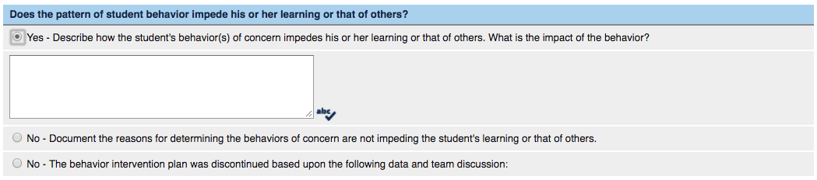

NO-Document the reasons for determining the behaviors of concern are not impeding the student’s learning or that of others.
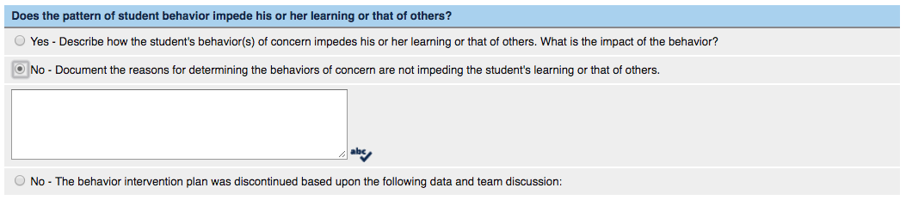

NO- The behavior intervention plan was discontinued based upon the following data and team discussion
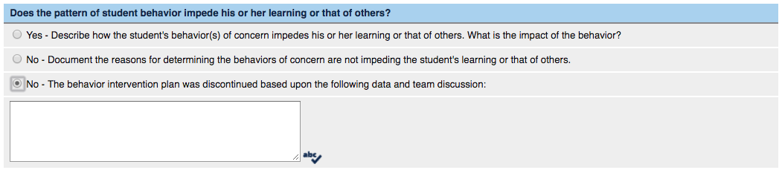

Case Conference Committee Decision
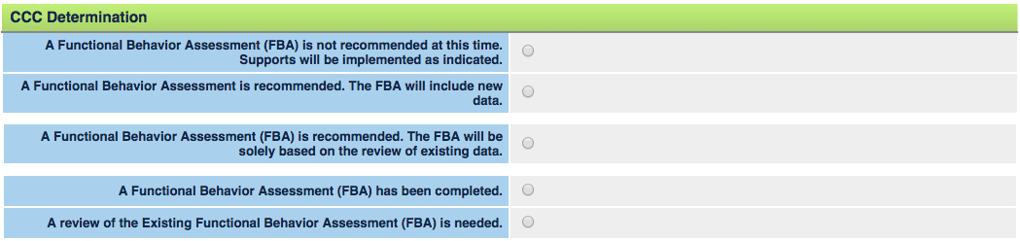

Choices | Choose this when
Choice #1: A Functional Behavior Assessment (FBA) is not recommended at this time. Supports will be implemented as indicated. | The student does not have a BIP and you are trying to determine if providing supports would improve the behavior.  An FBA is not needed but environmental supports and accommodations can be given to the student to address low level Tier 1 behaviors (not following directions the first time asked, off task, ) or Tier 2 behaviors (refusal to comply, inappropriate actions, escalating behaviors).  If giving accommodations or environmental supports for a Tier 2 behavior then a behavior goal is required.
Choice #2: A Functional Behavior Assessment is recommended. The FBA will include new data. | A new pattern of behavior is evident, an additional behavior is evident, or if an FBA has never been completed.  A Notice of Re-Evaluation must be generated in the IIEP system.
Choice #3: A Functional Behavior Assessment (FBA) is recommended. The FBA will be solely based on the review of existing data. | There isn’t an FBA already  The current FBA needs to be revised/ updated and you have existing data  - Recorded documentation for  - Anecdotal records  - Behavior goal progress  - Response to interventions, supports, accommodations already tried  - Powerschool data (attendance, behavior log entries, attendance, previous testing results, independent evaluation)
Choice #4: A Functional Behavior Assessment (FBA) has been completed. | The FBA had been completed previously because the student has a BIP and you need to add the data into IIEP.  Reconvening a CC after having completed an FBA (Choice #2) or revising/updating an existing FBA (Choice #3)  Do not choose this unless you have chosen ‘A review of the existing Functional Behavior Assessment is needed’
Choice #5: A review of the existing Functional Behavior Assessment (FBA) is needed. | The current FBA needs to be reviewed to determine if the school can address all of the current needs and behaviors.

Choice #1: A Functional Behavior Assessment (FBA) is not recommended at this time. Supports will be implemented as indicated
- You will need to choose one or more of the following three choices:
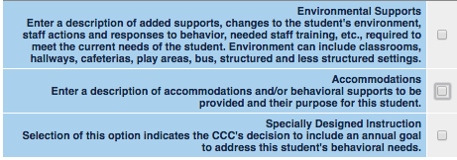
- Environmental Supports
- Accommodations
- You need to state if accommodations are behavioral or academic
- When you choose this, the additional accommodations that have been entered on the Provisions tab will be listed here, they are the same box so make sure to not delete the ones you want to keep and just label them as academic or behavioral
- Specially Designed Instruction
- There is no narrative box here. The SDI will be entered for the behavior goal that you write in the Goals tab

Once you have completed the information for supports you will need to indicate the plan(s) to monitor the effects/impact of the supports. You can add additional plans by clicking on ‘Add Additional Plans’.

A CC will need to be held in 4-6 weeks (minimum 4 weeks, best practice is 6 weeks) to evaluate the data that has been collected and determine if the supports were effective.

If you choose ‘Other’ as your selection in any area, you must provide a detailed description.

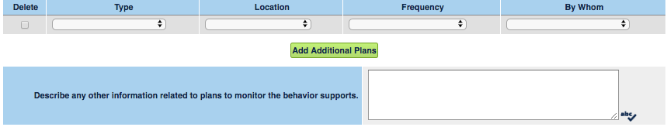

Type | Location | Frequency | By Whom
*Rubric/Rating Scale  *Frequency Duration Chart  *Scatterplot  *Task Analysis/Checklist  *Trial Data  *Tally Sheet  *Other: | *Specific Class or  Period  *Hallways  *Lunchroom  *Playground  *Bus  *Other: | *Each Work Period or  Class  *Specific Period/Class  *Morning  *Afternoon  *Daily  *Weekly  *Other | *TOR  *TOS  *Instructional Assistant  *School Counselor  *Mental Health/ Social  Worker  *Administrator  *Student  *Other:

Choice #2: A Functional Behavior Assessment is recommended. The FBA will include new data.

If you are going to choose #2, you will need to contact your school psychologist before the conference so they can recommend what data will need to be collected.

The school psychologist will complete the Notice of Re-Evaluation, which will generate a 50 day timeline that MUST be signed by a parent before you can collect ANY data.

This text box needs to explain the reason(s) why a new FBA and new data are needed.

Describe the new data you will collect in order to re-evaluate the student. You must describe the information you are looking to collect as it relates to the behaviors of concern.

You will need to choose one or more of the following three choices to implement for the student while you are conducting the FBA
- Environmental Supports
- Accommodations
- You need to state if accommodations are behavioral or academic
- When you choose this, the additional accommodations that have been entered on the Provisions tab will be listed here, they are the same box so make sure to not delete the ones you want to keep and just label them as academic or behavioral
- Specially Designed Instruction
- There is no narrative box here. The SDI will be entered for the behavior goal that you write in the Goals tab

Once you have completed the information for supports you will need to indicate the plan(s) to monitor the effects/impact of the supports. You can add additional plans by clicking on ‘Add Additional Plans’.

If you choose ‘Other’ as your selection in any area, you must provide a detailed description in the text box.

Data will need to be collected for 4-6 weeks. Four weeks is the minimum amount of time to collect data and 6 weeks time is best practice.

Type | Location | Frequency | By Whom
*Rubric/Rating Scale  *Frequency Duration Chart  *Scatterplot  *Task Analysis/Checklist  *Trial Data  *Tally Sheet  *Other: | *Specific Class or  Period  *Hallways  *Lunchroom  *Playground  *Bus  *Other: | *Each Work Period or  Class  *Specific Period/Class  *Morning  *Afternoon  *Daily  *Weekly  *Other | *TOR  *TOS  *Instructional Assistant  *School Counselor  *Mental Health/Social Worker  *Administrator  *Student  *Other:

The TOR is responsible for conducting the FBA with the help of the student’s team. As a team they will work together to complete the school corporations FBA form and develop a proposed BIP. This is a TEAM process and should never be left to the TOR to solely complete.

Once the team has completed the corporation FBA form a case conference needs to be convened to review the results of the FBA and the proposed BIP.

The FBA will need to be uploaded into Indiana IEP with the title “FBA completed on (date)”

Choice #3: A Functional Behavior Assessment (FBA) is recommended. The FBA will be solely based on the review of existing data.

Consent is NOT needed for this but you MUST be sure to only use existing data that has already been collected. See list of types of existing data.

Before holding a conference, meet with the student’s team to determine if you have enough existing data to complete all of the components for an FBA.

At the CC when it it proposed to complete a new FBA using existing data, a date must be set to reconvene in 4-6 weeks in order to review the FBA data and make any revisions to the IEP and the students BIP.

This text box needs to explain the reason(s) why a new FBA and a review of existing data are needed to develop the BIP.

In this box you will input the following statement, “A review of student data may include, but is not limited to the following: education, behavior, and attendance records, progress reports, medical history, recent academic assessments, historical grades, etc.”

You will need to choose one or more of the following three choices to implement for the student while you are conducting the review of existing data for the FBA:
- Environmental Supports
- Accommodations
- You need to state if accommodations are behavioral or academic
- When you choose this, the additional accommodations that have been entered on the Provisions tab will be listed here, they are the same box so make sure to not delete the ones you want to keep and just label them as academic or behavioral
- Specially Designed Instruction
- There is no narrative box here. The SDI will be entered for the behavior goal that you write in the Goals tab

Once you have completed the information for supports you will need to indicate the plan(s) to monitor the effects/impact of the supports. You can add additional plans by clicking on ‘Add Additional Plans’.

If you choose ‘Other’ as your selection in any area, you must provide a detailed description in the text box.

Data will need to be collected for 4-6 weeks. Four weeks is the minimum amount of time to collect data and 6 weeks time is best practice.

Type | Location | Frequency | By Whom
*Rubric/Rating Scale  *Frequency Duration Chart  *Scatterplot  *Task Analysis/Checklist  *Trial Data  *Tally Sheet  *Other: | *Specific Class or Period  *Hallways  *Lunchroom  *Playground  *Bus  *Other: | *Each Work Period or Class  *Specific Period/Class  *Morning  *Afternoon  *Daily  *Weekly  *Other | *TOR  *TOS  *Instructional Assistant  *School Counselor  *Mental Health/ Social  Worker  *Administrator  *Student  *Other:

The TOR is responsible for conducting the FBA with the help of the student’s team. As a team they will work together to complete the school corporations FBA form and develop a proposed BIP. This is a TEAM process and should never be left to the TOR to solely complete.

Once the team has completed the corporation FBA form a case conference needs to be convened to review the results of the FBA and the proposed BIP.

The FBA will need to be uploaded into Indiana IEP with the title “FBA completed on (date)”

Choice #4: A Functional Behavior Assessment (FBA) has been completed.
Choice #5: A review of the existing Functional Behavior Assessment (FBA) is needed.

You will need to choose ONE:
- Functional Behavior assessment was completed using the IIEP System
- Functional Behavior Assessment was completed without using the IIEP System
  - ALWAYS choose this one if it is an initial FBA or a new FBA

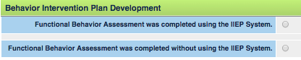

Upload the hard copy of the FBA form into IIEP (ONLY for Choice #4)

CCC Analysis of Functional Assessment Data

Interfering Behaviors
Describe the behaviors that are interfering with learning in specific measurable terms
  - This is where you define the behavior and address frequency, level of intensity, duration, etc
    - What does it look like?
    - How often does it occur?
    - How long does it last?
    - In what ways does it impede the student’s learning or learning of others?
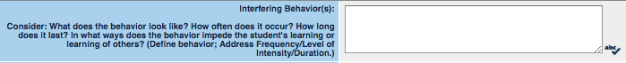

Precipitating Factors
Describe the precipitating factors
- Medical concerns (diagnoses, medications, medical history, etc)
- Sensory Issues (proprioceptive, vestibular, auditory, visual, etc)
- Communication Needs (non-verbal, body language, gestures, etc)
- Stressful events (foster care, residential treatment, divorce, death, etc)

Setting Events
Under what conditions does the behavior occur?
When and where would the behavior be MOST and LEAST likely to occur?
- Presence or absence of specific people
- Time of day or week
- Structured vs unstructured settings
- Subject area/Curriculum setting
- Change in routine

Antecedents
These are the triggers for the behavior. Given all of the conditions above, what
action/event makes that behavior occur?
- Describe (in detail) what is happening right before the behavior
- What are staff and students doing?
- What is going on in the room?
  - Teacher directives, questions, or corrections being given
  - Transition to a new activity

Maintaining Consequences
- Why does the student continue to do the behavior?
- What’s the payoff for the student?
- What changes in the environment after the behavior that makes the student likely to do it again?
  - Access to or escape from student or teacher attention
  - Access to or escape from tasks/demands

Related Deficits
- What skill(s) is the student missing or needing to practice that may contribute to the occurrence of the behavior?
  - Academic
  - Social
  - Communication Deficits

Summary and Hypothesis
- NOTE: Talk to the student. They know why they are doing what they are doing. Start the conversation and dig deeper, don’t assume anything. Someone that they trust and that has a relationship with them needs to talk to them.
- After reviewing all assessment information, fill in descriptions to complete the following statement:
  - When ____ the student ____ in order to get ____.
- When ____ (describe the setting events associated with the problem behavior)
- The student _____ (describe the problem behavior in specific, measurable terms)
- In order to get _____ (describe the function/goal of misbehavior-what was gained or avoided)
- Examples:
  - When the class does round robin reading Carmen echo’s the student reading aloud to get the attention of peers in her Social Studies class.
  - When Zach is given a directive or request from authority he will exhibit disruptive behaviors of making noises/inappropriate comments, touching/poking others, blurting things out in class, and randomly throwing objects in the classroom in order to avoid instruction/work and gain attention.
  - For two days following the transition between parent homes, Marcie is verbally aggressive with supervisory adults, argues with peers, has missing materials and doesn’t complete class or homework assignments. Marcie’s inability to cope with the weekly transition interferes with participating in classes, learning activities, work completion, and her interactions with peers and teachers.

***Hypothesis is the end of the Functional Behavior Assessment***
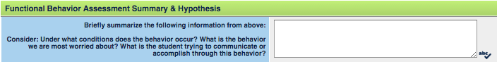

Developing a Behavior Intervention Plan

Copy and paste the hypothesis into this text box
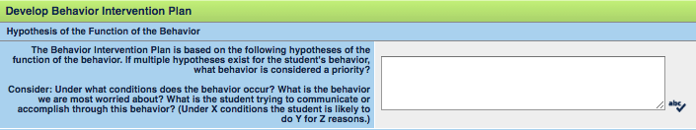

Proactive Strategies
Replacement behaviors and skills to be taught and learned
- If the student doesn’t know how to do a behavior then the teacher must teach the behavior
- If the student does know how to do the behavior, but not when to do it, the teacher will teach the student a cue
- If the student knows how and when to do the behavior but forgets or if they are unaware of their behavior, the teacher will teach the student to monitor their behavior
- How can the student get the same need met in a more appropriate way?
  - Identify the skills to be taught by staff and learned by the student
  - What do typical students do to meet the same needs?
    - Raise hand
    - Ask questions for understanding
    - Use conflict resolution strategies

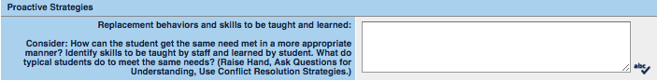

Instructional Strategies
- This is your teaching plan for the replacement behavior. You MUST be specific in how and who will teach the behavior to be learned and when it will be taught
  - Is this a skill deficit or performance deficit?
  - How do we plan to teach this skill/behavior?
  - When will we teach the skill/behavior?
  - How will we model the skill/behavior?
  - How will we engage the student?

Antecedent Strategies
- You will need to include the environmental supports and accommodations that have already been effective for the student
- What can we do in the environment to support learning?
- What things in the environment would make it more likely for the positive/replacement behavior to occur?

Positive Consequence Strategies
- When the student is using the newly learned skill, how can we make sure he or she receives the desired function?
  - Reinforcers need to be individualized as much as possible and developed with student input if they’re going to be effective.
    - Using the Student Reinforcement Survey from the FBA process will help determine reinforcers appropriate to the student
  - Reinforcement needs to be delivered immediately
    - When building a new behavior reinforcement should be delivered continuously
    - When maintaining an existing behavior reinforcement should be delivered intermittently

Negative Consequence Strategies
- Natural and logical consequences are the most effective in order to teach students they can control their behaviors and have the power to choose their actions
  - Natural consequences are outcomes that happen as a result of behavior that are not planned or controlled
    - Examples:
      - If you don’t smile and be nice to people they won’t want to be your friend
      - If you intentionally break pencils then you will have to use broken pencils
  - Logical consequences are imposed by staff and help children look more closely at their behaviors and consider the results of their choices. They are planned in advance with student input
    - Examples:
      - If you use obscene language you must apologize
      - If you hit others you cannot be with them for awhile.
- When the student is not using the newly learned skill, how can we make sure he or she does not receive the desired function?
- Examples:
  - Out of school suspension (OSS) not to exceed 10 days in an academic school year.
  - Isolation at home to be assigned at administrator discretion if (student) cannot be de-escalated.
  - If (student) misses more than 5 minutes of a class period due to non-compliance he or she will make up the time in after school detention.
- Crisis Plan, Elopement Plan, and Safety Plan information MUST be included in this text box also
  - You will need to type the header in bold and then detail the plan
    - Crisis Plan
      - A crisis plan is an action plan that is needed for times when a student may be at risk of harm to self or others and it needs to address the following:
        - How staff will contact the crisis team in the building and call for assistance
        - How bystanders in the room/area will be removed and to where
        - What de-escalation strategies staff will use to aid in calming the student (relaxation, self-calming, active listening, etc)
        - Non-verbal and verbal communication skills staff will demonstrate during the incident (maintain calm demeanor, CPI supportive stance, appropriate tone and volume, etc)
        - What triggering events have been identified so staff can avoid a reaction
        - How to manage the environment during the situation for potential risks (remove items that could be dangerous, move furniture out of the way, etc)
        - Suggested choices of appropriate alternative behaviors. The student needs a way to redeem self or to relent in a non-threatening way
        - How sufficient time will be used for the student to calm down before staff expectations are reiterated
        - As a last resort and when imminent risk of injury exists, how staff will use CPI training to prevent injury to student or others
    - Elopement Plan
      - An elopement plan is written for students that elope and leave their designated/assigned area. The plan MUST include:
        - Summary and pattern of elopements
        - How building staff are notified of a missing student
        - How all staff in the building can be used to search the building and specific staff assignments of what areas to search
        - How staff will relay information to office, parent, school security, and/or police
    - Safety Plan
      - A safety plan is written for students that pose a potential risk of injury to self or others and require more supervision at all times. The plan needs to include:
        - Staff assignments for how the school will increase the level of supervision of the student
        - How to handle transitions in the building, including any strategies needed for specific settings
        - How all staff that work with the student are aware of these protective measures
        - How you will limit or deny students access to identified items when necessary
        - Which staff will monitor and search student and possessions

**The need for a crisis plan must also be documented on the provisions tab. On the provisions tab in the text box that opens up type: “Provisions to be provided as part of the Crisis Plan can be found under Negative Consequence Strategies as part of (student’s) BIP. “

Behavioral Goals/Skills to be Taught and Learned
- When a student has a Behavior Plan they MUST have a behavior goal
- The plan MUST match the goal.
- Goals should focus on identified replacement behaviors
  - Under X conditions the student will do Y at Z to this level of performance
- You will need to indicate which goals are written to support the Behavior Intervention Plan by checking the box, “A goal has been/will be written to support the identified replacement behaviors.”
- Under what conditions will the replacement behavior occur?
- What replacement behavior is being taught?
- How frequently must we observe, collect, and review data to inform our decision?
  - Consider both legal and best practice timelines for data collection

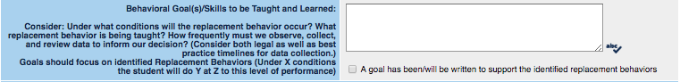

Available Local and State Resources for Families
- Document information for local and regional services that families may wish to pursue, at their cost, beyond the IEP services
- Choose service providers that directly relate to the student’s behavioral needs
- You MUST start this section with the following statement:
  - Parents may wish to consider pursuing the following options at their expense…
    - Provide a brief description of the service(s) AND provide the contact information for the service(s)
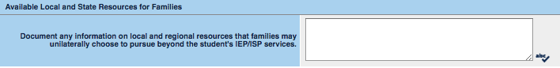

This behavior intervention plan was reviewed by the CCC.
- The CCC determined to implement the BIP as written.
  - Check this if no changes were made to the BIP at the CC
- The CCC determined to implement the BIP with revisions.
  - Check this if the committee agreed to revisions of the BIP at the CC

When the BIP is complete, you will need to return to the Goals tab and the Provisions tab
- Goals tab
  - In the details of each goal, you will have to determine if the goal is to support a behavioral need
  - Check the box in the appropriate goal(s)
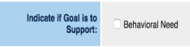

- Provisions tab
  - In the last column of services, you will need to determine if the service is to support a behavioral need
  - Check the box for the corresponding service(s)
